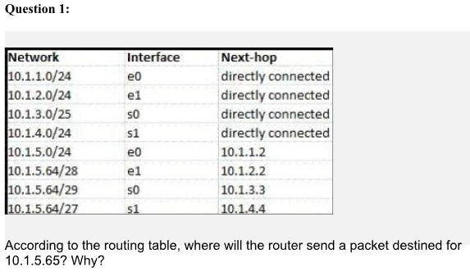

Answer: 10.1.5.64/29 - s0 - 10.1.3.3

Reason:

e1, s0 and s1 are all suitable as they are within the subnet range, however the answer is s0 as it has the longest prefix at 29 bits, so it is the most specific route match.

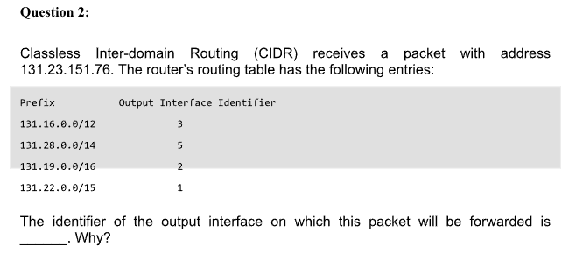

Answer: 131.19.0.0/16 - Output interface identifier = 2

Reason:

Both 131.16.0.0/12 and 131.19.0.0/16 match, but the packet will be forwarded using Interface 2 because it matches the longest prefix 131.19.0.0/16

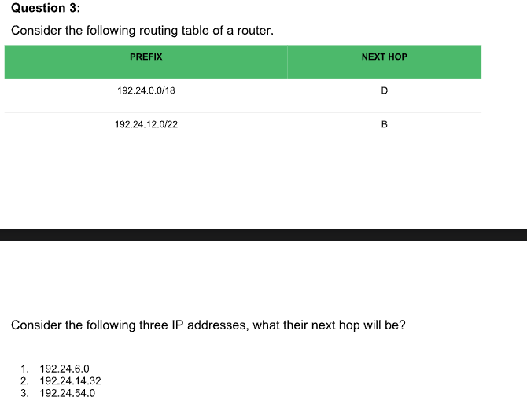

Answer: 1 = D 2 = B 3 = D

Reason:

Range for D = 192.24.0.0 to 192.24.63.255

Range for B = 192.24.12.0 to 192.24.15.255

1 – 192.24.6.0 falls within the subnet range of 192.24.0.0/18 and not the other given range.

2 – 192.24.14.32 falls withing both ranges, but hop B is chosen as the route is more specific.

3 – 192.24.54.0 falls withing the 192.24.0.0/18 and not the other given range.

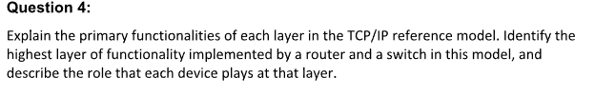

Answer:

1. **Application Layer**:

The user/consumer side services such as web browsing and emails.

Protocols - HTTPS, DNS, etc.

1. **Transport Layer**:

Responsible for reliable data delivery between devices, flow control and possible error checking.

Protocols - TCP and UDP.

1. **Internet Layer**:

Makes sure packets are routed correctly across networks.

Protocols - IPv4, IPv6, ARP and ICMP.

1. **Network Access Layer**:

For the physical addressing (MAC address) and hardware level communication.

Protocols – Ethernet and Wi-Fi.

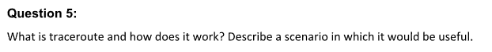

Answer:

A traceroute is a network diagnostic tool used to trace the path that packets take from a source to a destination across an IP network. It keeps track of all the routers that it traverses to reach its destination.

This can be useful to diagnose or identify possible network problems.

Example scenario:

A developer cannot access their own site, they’re worried that some kind of error must have occurred. They send out a traceroute just to be sure and based on its journey and the information it relays back to them they're able to identify that the local network hub must be down as the traceroute was able to hob from their home router to the local network hub but not able to hob to any other destination once reaching that point.

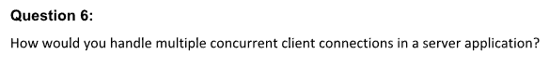

This depends on the circumstances, if persistent connections, real time updates and scalability are required, then I would choose to use a WebSocket which are extensions of asynchronous programming and are able to handle thousands of simultaneous connections at once.